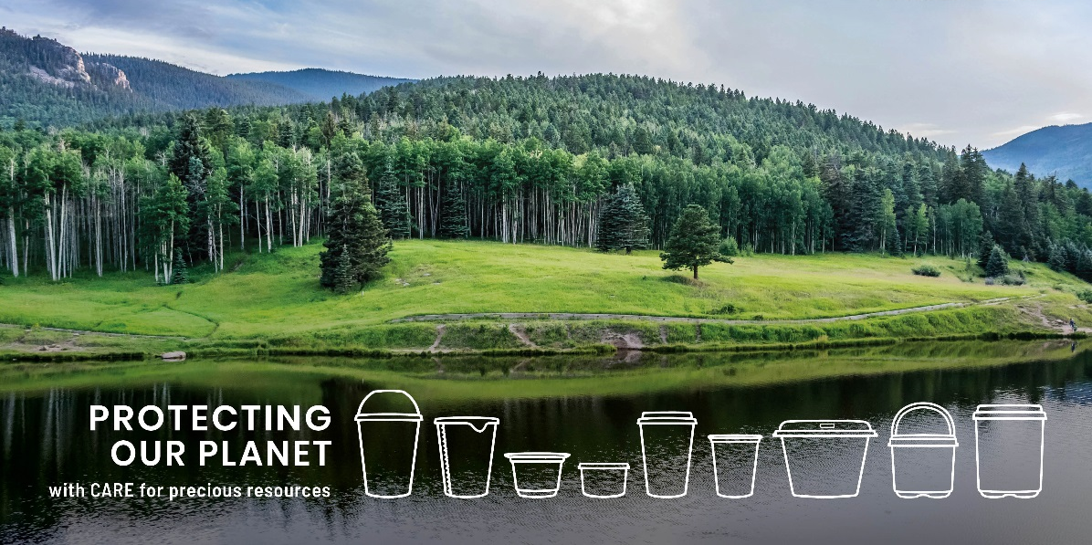
September 9th, 2020
WE C.A.R.E.

PACCOR has just introduced a long term and sustainable approach that focuses on protecting people and the planet: the new C.A.R.E. strategy, aligning with the EU regulations and the UN sustainable development goals. From design, production and disposal, to reprocessing, the leading global manufacturer of valuable packaging solutions is setting higher standards of sustainability.
Plastic waste in the environment, climate change and the demand for transparency are significant trends affecting the food and packaging industry. In response to the public outcry, governments introduced regulations, including the EU Single-Use Plastic and Zero Waste Europe directives, to support the circular economy for plastics. As the leading manufacturer, a socially responsible company, a signatory of the New Plastic Global Commitment Agreement, and a participant of multiply eco-friendly initiatives, such as “Operation Clean Sweep®“ and “Holy Grail 2.0”, PACCOR Group decided to head up these new challenges.
The company has invested hundreds of millions of euros in R&D to change technology and production lines to focus on the recycling packaging process, switching from disposable products to reusable packaging and increasing production of plastic packaging using post-consumer materials while maintaining the same quality. To achieve the main goal, the production of fully secure plastic packaging and to further use it in the manufacturing of 100 % reused, recycled, or composted waste material by 2023, PACCOR has developed and recently introduced the new C.A.R.E. (Circularity, Alliances, Resources, and Employees) strategy, with the overall goal of protecting the most precious ones and assets.
“PACCOR, with more than 3,000 dedicated employees in 15 countries worldwide, is the leading international player in the packaging industry. Therefore, we know that we have a great responsibility towards people and the environment. Everything we do contributes to the protection of valuable products in the food and non-food markets and to a sustainable future we can be proud of,” said Andreas Schuette, Chief Executive Officer of the PACCOR Group. “Our company leads the transition towards a circular economy with a safe, committed, diverse and capable workforce. Because we believe this is the best way to achieve real change in the industry and to create shared value for all our stakeholders, the society and to fully implement sustainability, we have introduced the new strategy,” summarized PACCOR’s CEO.
C.A.R.E. is a driver for PACCOR’s growth, innovation and productivity and is an essential part of employees‘ value proposition. As a part of the new strategy, the manufacturer fosters long-lasting and honest partnerships with the overall goal of protecting valuable products, future resources and the economic efficiency of customers. The company also CAREs for resources and all the materials which are used in the whole process, eliminating waste, redundant materials and reducing variable costs e.g. by 15 % relative carbon cradle-to-grave reduction, 25 % relative waste reduction, 10 % relative energy reduction by 2025 compared to 2019 and 100 % closed water loops.
“C.A.R.E. is about quickly recognizing societal concerns, such as the pressures of population growth, the expansion of human consumption and the limitations of traditional economic models, including packaging systems. It is about reacting to these existential challenges with urgency through business innovation and groundbreaking circular offerings for our customers, supporting rapid business adaptation and first-mover business opportunities,” pointed out Caterina Camerani, the VP Group Sustainability at PACCOR. “The new strategy is about partnering along the value chain and with organisations to create sustainable value for all our stakeholders and deliver the necessary change, at scale,” added Ms. Camerani.
More about the C.A.R.E. strategy, click here.

MEDIA CONTACT:
Sonja Teurezbacher
Vice President Group Communications & Marketing
communication@paccor.com

ABOUT PACCOR
At PACCOR we create innovative and sustainable packaging solutions for the consumer, food and foodservice market. Our overall goal is to protect what is worth being protected: our planet, our partners’ products and our employees. We have high expertise in developing and providing valuable rigid plastic packaging products. Our solutions meet current market trends by constantly thinking outside the box. With more than 3,000 dedicated employees in 15 countries, PACCOR is a global player in the packaging industry. Everything we do contributes to the protection and hygienic safety of valuable products. PACCOR leads the transition towards a circular economy. Because we believe this is the best way to achieve real change in the industry and to create shared value for all our stakeholders and society.
More: https://www.paccor.com/

