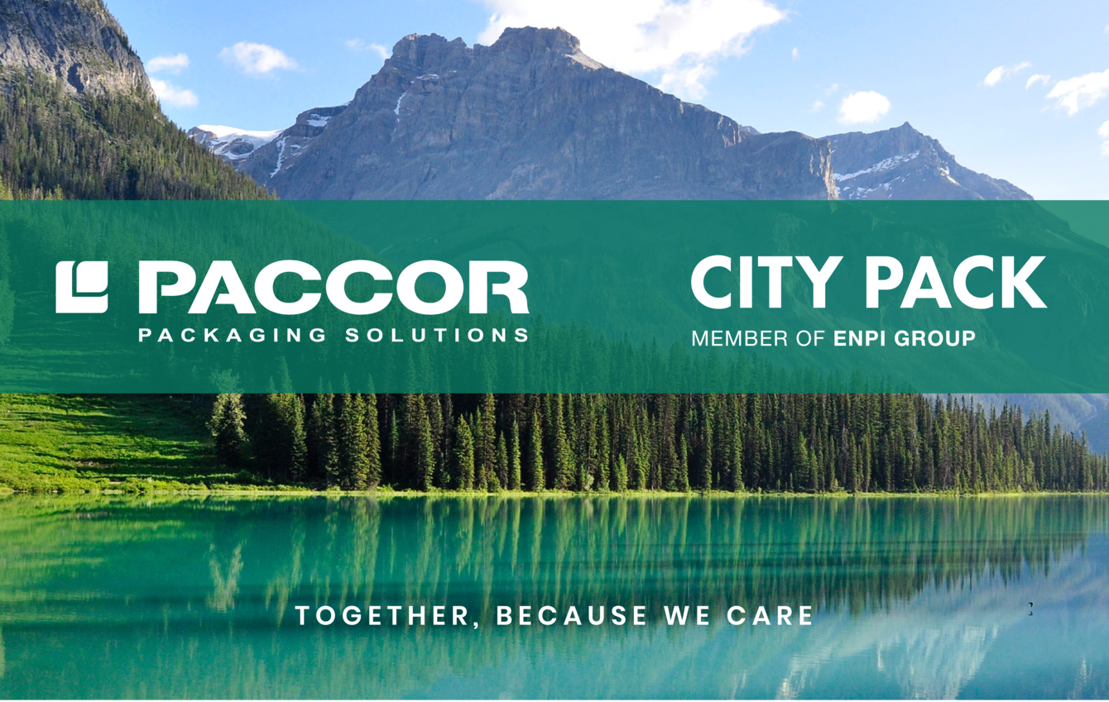
December 17th, 2020
TOGETHER, BECAUSE WE CARE

PACCOR, a global player in the packaging industry, and CITY PACK (member of ENPI GROUP) are proud to announce their exclusive partnership, that will connect European standards of sustainability while capturing regional growth potential in the Middle East and Africa. PACCOR’s innovative environmentally friendly products will be available to all CITY PACK customers in the region, driven by the shared value of responsibility towards our families and planet.
We are glad to inform you about a new distributor we now cooperate with. CITY PACK is our new business partner for the distribution of PACCOR’s food service products in the Middle East. CITY PACK is a business unit of the Emirates National Factory for Plastic Industries Group (ENPI GROUP) located in Sharjah, United Arab Emirates.
CITY PACK offers a wide range of over 3,500 products from plastic and catering equipment (plastic & aluminum containers, foils, cling films, paper & foam cups, deli take away containers, etc.) to biodegradable as well as hygiene products. They provide their solutions to hotels, hospitals, airline gourmet, ship chandlers restaurants, and several other food chains. The company is dedicated to researching new innovative techniques in the market that meet the multiple and diverse needs of customers and clients.
“We are very pleased to have CITY PACK on our team. I know that they will be equally proud of our products. Since building and maintaining personal, professional relationships is so critical we are sure that the partnership with CITY PACK will boost our selling success in this new region," explains Nicolas Lorenz, Chief Commercial Officer at PACCOR.
More about the CARE strategy, click here.

MEDIA CONTACT:
Sonja Teurezbacher
Vice President Group Communications & Marketing
communication@paccor.com

ABOUT PACCOR
At PACCOR we create innovative and sustainable packaging solutions for the consumer, food and foodservice market. Our overall goal is to protect what is worth being protected: our planet, our partners’ products and our employees. We have high expertise in developing and providing valuable rigid plastic packaging products. Our solutions meet current market trends by constantly thinking outside the box. With more than 3,000 dedicated employees in 15 countries, PACCOR is a global player in the packaging industry. Everything we do contributes to the protection and hygienic safety of valuable products. PACCOR leads the transition towards a circular economy. Because we believe this is the best way to achieve real change in the industry and to create shared value for all our stakeholders and society.
More: https://www.paccor.com/

