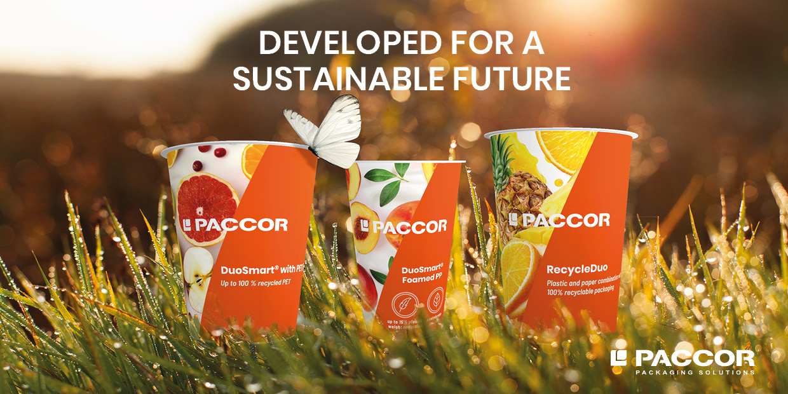

April 15, 2021, Dusseldorf, Germany

PACCOR TO PRESENT NEW GENERATION OF DUOSMART® SOLUTIONS

PACCOR is continuously searching for new materials, working to improve upon current materials, developing new technologies and bringing innovative product packaging solutions to life. Now one of the leading global players in the packaging industry is ready to present great additions to its DuoSmart® range. Coming to the market is RecycleDuo which stands for our DuoSmart® (DS) products without glue and new DuoSmart® solutions with rPET (recycled Polyethylene terephthalate) or foamed PP (Polypropylene) inlets. These products play an important role in the company’s CARE strategy and help achieve PACCOR’s goal of recyclability in practice and at scale for all products by 2023, ahead of the EU timescale.

DuoSmart® is a modern packaging solution that combines the advantages of paper with the functionality of plastic. It contains up to 50 % less plastic compared to standard injection molded packaging, and with a “zip”, the inner cup and paper banderole can be easily separated into different waste streams. The brand addresses concerns about the environment with a sustainable biopolymer option, and offers PP, PET and barrier PP or more demanding shelf-life requirements. The packaging is the perfect choice to protect the nutritional value, color, aroma, and taste of food products, including those stored in ambient, chilled, or frozen conditions. Hot filling and microwaving are also options. Available in a wide range of sizes, DuoSmart® runs on standard food industry filling lines, with fast and smooth performance.

Already available are varied shapes and sizes of cups in standard and light versions to store different products for dairy, convenience food, dry food, food service and pet food. The DuoSmart® standard version design provides an efficient location for the product’s bar code, it being at the bottom. Therefore, ensuring easy scanning, advantageous position, and above all, does not disturb the outer artwork. Together with the various intriguing design layout opportunities, DuoSmart® offers customizable see-through windows giving the consumer a view of what they will be purchasing. PACCOR’s designs come in many shapes and sizes, as well as allowing the customers to determine how they want to showcase their products.

Three innovative variants now expand PACCOR’s DuoSmart® portfolio.

RecycleDuo is in progress to be implemented first on all PP DuoSmart® Light references. This development without using glue allows customers to separate the plastic inlet and the cardboard segment more easily without any paper remains on the plastic cup and therefore improves recyclability.

DuoSmart® with rPET inlet responds to the market request of recycled content increase which today is mainly possible with rPET reincorporation up to 100 %.

DuoSmart® with foamed PP inlet makes up to 16 % less CO₂ emissions possible and 15 % less plastic needed compared to the production of traditional DuoSmart® cups.

The new generation of DuoSmart® solutions allow having the Digimarc barcode printed on the paper outer layer and engraved on the plastic cup. It can be scanned with any smartphone camera and will provide the consumers as well as the disposable companies with information about the respective packaging. Therefore, the combination of DuoSmart® and the Digimarc Barcode will provide everyone with relevant packaging information anywhere and anytime.

“These new products are supporting PACCOR’s CARE strategy by providing leading circular offers to our customers,” adds Nicolas Lorenz, CCO of PACCOR. “We are constantly striving to not only achieve our ambitious sustainability goals, but also focus on helping our customers to reach their environmental targets as well. We want to act together responsibly as an entire industry,” concludes Nicolas Lorenz.

MEDIA CONTACT:
Sonja Teurezbacher
Vice President Group Communications & Marketing
communication@paccor.com

ABOUT PACCOR
At PACCOR we create innovative and sustainable packaging solutions for the consumer, food and foodservice market. Our overall goal is to protect what is worth being protected: our planet, our partners’ products and our employees. We have high expertise in developing and providing valuable rigid plastic packaging products. Our solutions meet current market trends by constantly thinking outside the box. With more than 3,000 dedicated employees in 15 countries, PACCOR is a global player in the packaging industry. Everything we do contributes to the protection and hygienic safety of valuable products. PACCOR leads the transition towards a circular economy. Because we believe this is the best way to achieve real change in the industry and to create shared value for all our stakeholders and society. More: https://www.paccor.com/

