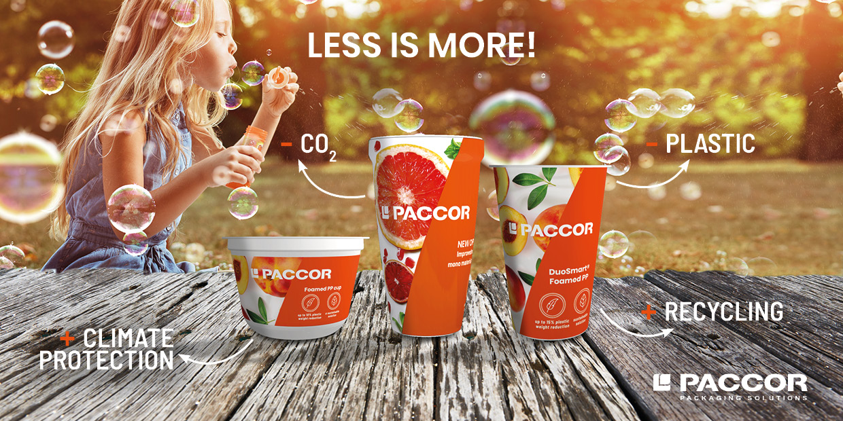

April 16, 2021, Dusseldorf, Germany

PACCOR TO PRESENT NEW SUSTAINABLE PP PRODUCTS

PACCOR has an extensive product portfolio offering many sizes and different shapes for a wide variety of contents. Nevertheless, as a leading global player in the packaging industry, the company is continuously searching for new materials that their packaging solutions meet current market trends. Now PACCOR is ready to present several new PP products developed in the last months: foamed polypropylene (PP) products and PP cups with oriented polypropylene (OPP) sleeves – a true pioneer performance. PACCOR’s solutions improve shelf life at lower carbon costs, thus contributing to the well-being of people and our planet.

The PP foaming technology allows a 10 to 15 % weight reduction of the products with full skeleton reincorporation and increased thermoforming cycle time. The cups are available in white or colored (non-transparent). This technology has been developed in PACCOR’s production site in Szombathely, Hungary, with a significant investment on an existing extrusion line.

“The results of the foamed PP cups are very satisfactory. Up to 16 % less CO₂ emissions when we produce our DuoSmart® solutions and 15 % less plastic needed compared to the production of traditional DS cups," outlines Yves Caunegre, Group Director Innovation at PACCOR.

PACCOR, an absolute pioneer in this field, is the first packaging manufacturer to offer OPP sleeves on PP cups which are detected as mono-material PP. The sleeves can be fully recycled and sorted together with the PP cup. Mono-material packaging is the best solution for the circular economy. Besides that, it offers unlimited decorating possibilities and is ideal for conical or curved cup shapes.

“These new products allow significant sustainability improvements compared to oriented polystyrene (OPS) and polyvinyl chloride (PVC) sleeves and support PACCOR’s CARE strategy by providing leading circular offers to our customers. Mono material solution can make sleeving interesting for other applications in conical or curved shape,” adds Nicolas Lorenz, CCO of PACCOR. “To support our customer’s sustainability agenda, life cycle analyses of our new products are available,” concludes Nicolas Lorenz.

MEDIA CONTACT:
Sonja Teurezbacher
Vice President Group Communications & Marketing
communication@paccor.com

ABOUT PACCOR
At PACCOR we create innovative and sustainable packaging solutions for the consumer, food and foodservice market. Our overall goal is to protect what is worth being protected: our planet, our partners’ products and our employees. We have high expertise in developing and providing valuable rigid plastic packaging products. Our solutions meet current market trends by constantly thinking outside the box. With more than 3,000 dedicated employees in 15 countries, PACCOR is a global player in the packaging industry. Everything we do contributes to the protection and hygienic safety of valuable products. PACCOR leads the transition towards a circular economy. Because we believe this is the best way to achieve real change in the industry and to create shared value for all our stakeholders and society. More: https://www.paccor.com/

