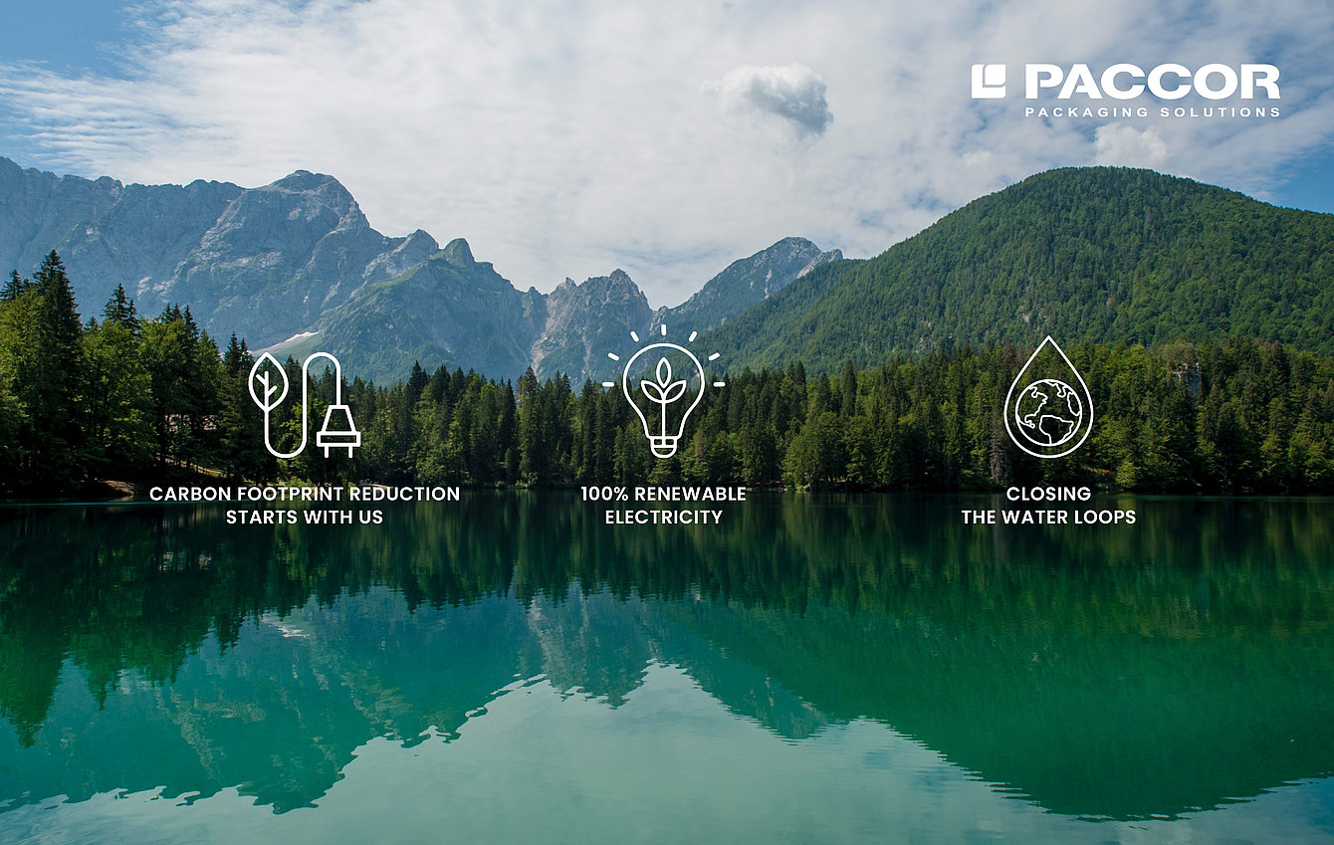

February 15th, 2021

PACCOR TAKES ANOTHER STEP TO
DELIVER ON THE EU’S COMMITMENT TO
GLOBAL CLIMATE ACTION UNDER THE
PARIS AGREEMENT
In September last year PACCOR, the leading global player in the packaging industry, launched its Sustainability strategy CARE (Circularity, Alliances, Resources, and Employees) with the overall goal of protecting the most precious ones and assets. As part of CARE, PACCOR outlined a detailed plan to get to carbon neutrality starting with announcing a renewable electricity commitment in October 2020 and committed to providing updates on the progress. The company has been working hard to turn its commitments into action and, today, PACCOR is announcing further steps taken on the path to be carbon neutral by 2050.

In order to deliver on its commitment, PACCOR has formulated a series of resource efficiency targets which have been operationalized across all businesses and will report on progress every year.

- 15% cradle-to-grave carbon footprint reduction per ton product by 2025
- 10% reduction in energy consumption per ton of product by 2025
- 100% renewable energy from over a three-year period starting from 2020
- 25% reduction in waste per ton of product and zero waste to landfill by 2025
- 100% closed water cycle in all production facilities by 2025

“While our goals on reducing carbon emissions and waste as well as energy and water use within CARE are challenging, they will enable us to continue making an important contribution to the sustainability challenges faced by our company, customers, and broader society. During 2020 we have achieved significant milestones and we are proud to say that we are over-achieving in our commitment,” outlines Andreas Schuette, CEO of PACCOR.

In 2019, PACCOR standardized the monitoring of the diverse energy, waste, and water tracking systems and in 2020 the company identified and implemented strategic energy waste and water reduction projects across all sites, as part of the resource efficiency program. Last year the expected energy efficiency improvement has been achieved and the overall renewable electricity share has been increased to 64%.

For 2021, PACCOR has secured additional renewable electricity up to 86% of all electricity use with 12 out of 16 plants now running entirely on renewable electricity, by guarantees of origin for renewable energy in accordance with the EU Renewable Energy Directive and in compliance with the quality criteria of the latest Green House Gas (GHG) Protocol Scope 2 of application.

“Furthermore, the renewable electricity we have purchased comes from power plants with high-quality sustainability attributes such as the guarantee of re-investment in new renewable capacity and additional measures for the preservation of biodiversity. In this way, we are further contributing to the implementation of SDG 7, on access to affordable, reliable, and sustainable energy, and SDG 13, on urgent action to combat climate change," concludes Caterina Camerani, VP Group Sustainability at PACCOR.

For further details and progress on CARE, see PACCOR’s first Annual Sustainability Report which will be published in April 2021.

MEDIA CONTACT:
Sonja Teurezbacher
Vice President Group Communications & Marketing
communication@paccor.com

ABOUT PACCOR
At PACCOR we create innovative and sustainable packaging solutions for the consumer, food and foodservice market. Our overall goal is to protect what is worth being protected: our planet, our partners’ products and our employees. We have high expertise in developing and providing valuable rigid plastic packaging products. Our solutions meet current market trends by constantly thinking outside the box. With more than 3,000 dedicated employees in 15 countries, PACCOR is a global player in the packaging industry. Everything we do contributes to the protection and hygienic safety of valuable products. PACCOR leads the transition towards a circular economy. Because we believe this is the best way to achieve real change in the industry and to create shared value for all our stakeholders and society.

More: https://www.paccor.com/

