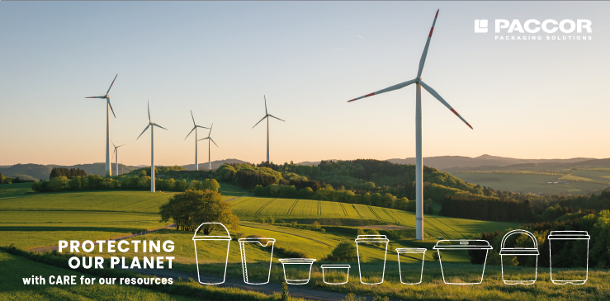
October 9th, 2020
PACCOR SIGNS RENEWABLE ELECTRICITY COMMITMENT

PACCOR, a leading international player in the packaging industry, is taking the next step in its C.A.R.E. strategy with the aim of protecting valuable resources, preventing waste, avoiding unnecessary materials and reducing energy consumption. At the same time, this strategy is a driver for growth, innovation and productivity and an essential part of the value proposition of the workforce.
By following the C.A.R.E. strategy, as part of our commitment to become carbon neutral by 2050, the company is making great strides in reducing the relative carbon footprint of cradle-to-grave by 15 % from 2019 to 2025.
“A roadmap has been defined for this in 2020 with the aim of reducing energy consumption per ton of product by 15 % by 2025. But reducing energy consumption alone is not enough. From 2020 onwards, the objective is to increase the share of renewable electricity to 100 % over a period of three years,“ explains Andreas Schuette, Chief Executive Officer at PACCOR.
Renewable electricity is secured by guarantees of origin for renewable energy in accordance with the EU Renewable Energy Directive and in compliance with the quality criteria of the latest Green House Gas (GHG) Protocol Scope 2 of application. Furthermore, the renewable electricity purchased comes from power plants with high-quality sustainability attributes such as the guarantee of re-investment in new renewable capacity and additional measures for preservation of bio-diversity.
At the same time, solar panels will be installed by the end of 2025 wherever technically and financially feasible. Currently, renewable energy already has a 64 % share, with 8 out of 16 plants running entirely on renewable energy.
Waste and water are other core areas of C.A.R.E. and PACCOR’s Resource Efficiency Program. The aim is to achieve a 25 % reduction in waste and zero waste to landfill by 2025. PACCOR is also working to establish a 100 % closed water cycle in all production facilities. The company has already invested hundreds of millions of euros in research and development to convert the technology and assembly line production to the recycling packaging process. The aim is to ensure that the same quality is maintained despite the change from disposable products to circular packaging and an increasing production of plastic packaging using post-consumer materials.
More about the CARE strategy, please click here.

MEDIA CONTACT:
Sonja Teurezbacher
Vice President Group Communications & Marketing
communication@paccor.com

ABOUT PACCOR
At PACCOR we create innovative and sustainable packaging solutions for the consumer, food and foodservice market. Our overall goal is to protect what is worth being protected: our planet, our partners’ products and our employees. We have high expertise in developing and providing valuable rigid plastic packaging products. Our solutions meet current market trends by constantly thinking outside the box. With more than 3,000 dedicated employees in 15 countries, PACCOR is a global player in the packaging industry. Everything we do contributes to the protection and hygienic safety of valuable products. PACCOR leads the transition towards a circular economy. Because we believe this is the best way to achieve real change in the industry and to create shared value for all our stakeholders and society.
More: https://www.paccor.com/

