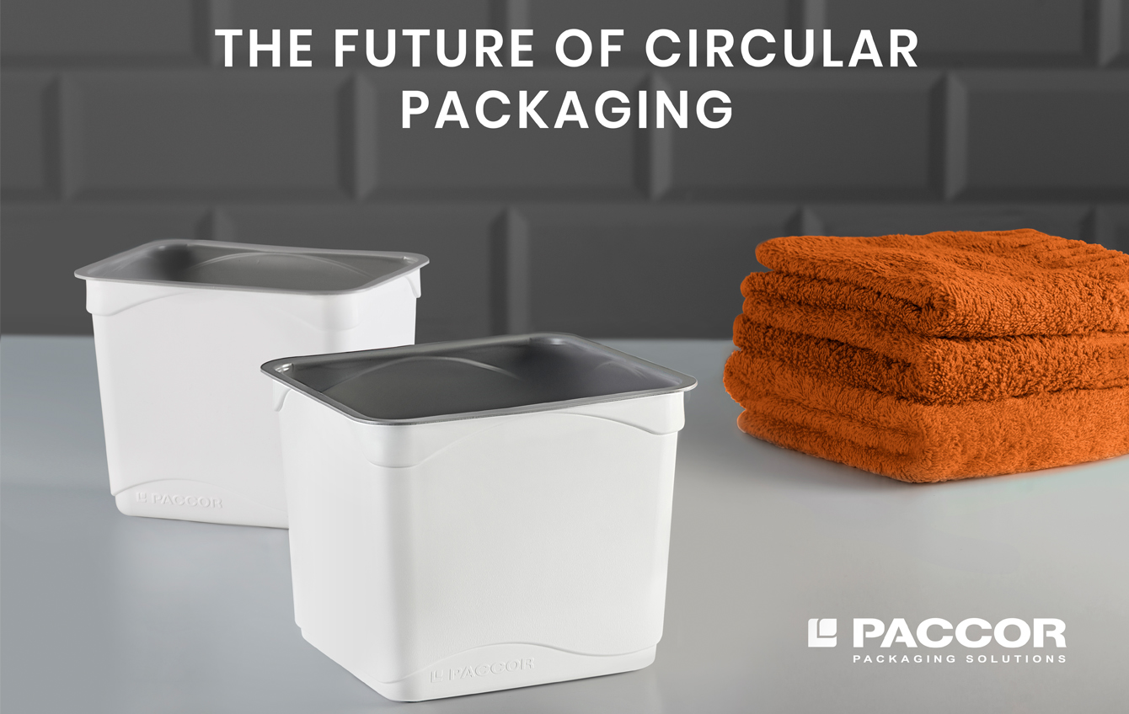

December 3rd, 2020

PACCOR READY TO PRODUCE
CONTAINERS WITH POST-CONSUMER
PP FROM TOTAL CIRCULAR
COMPOUNDS®
PACCOR, a global player in the packaging industry, is again leading technological change from linear to circular plastics. Thanks to a fruitful collaboration with Total, a major French energy player, PACCOR is now able to produce Polypropylene (PP) containers including recycled material of which 37 % households’ waste, with mechanical and appearance properties equivalent to those of containers made of virgin resin for non-food applications.

In order to reach 100 % of packaging containing recycled material by 2025, PACCOR decided to tackle, in collaboration with Total, the technical challenge of producing thermoformed PP containers using post-consumer resin. PACCOR and Total had to make use of all their formulation and processing expertise so that PP packaging users can also start closing the recycling loop leading from one used container to a new one.

"We are proud that our collaboration with Total enabled us to make this ground-breaking circular offering available to our customers, for non-food applications, and eager to start produce rPP containers for them," explains Andreas Schuette, CEO of PACCOR.

PP packaging is very different depending on the application scope (food or non-food) and protection properties which induces a high variability in raw material made of post-consumer waste. That is why PACCOR is simultaneously exploring ways to further increase PCR content and is confident in its ability to offer, within months, PP packaging with 50 % of PCR.

"We are very happy that Total could help PACCOR produce containers incorporating post-consumer PP using our Total Circular compounds®. Our goal is to enlarge the accessible market for recycled plastics with high-performing products, which was demonstrated successfully through this project. This is fully in line with Total’s ambition of producing 30 % recycled polymers by 2030," adds Jean Viallefont, Vice President Polymers Europe & Orient at Total.

PACCOR’s ambition is also to develop food approved rPP and to provide the PP value chain with quality sorting solutions, such as the Digimarc Barcode, in order to deliver change at a wide scale.

"When it comes to fundamental changes, collaboration is key. This is why we are committed to partner with forward-thinking players all along the value chain," concludes Marketa Voglova, VP Group Procurement at PACCOR.

PACCOR MEDIA CONTACT:
Sonja Teurezbacher
Vice President Group Communications & Marketing
communication@paccor.com
TOTAL MEDIA CONTACT:
Nancy van Heesewijk, EMG
nvanheesewijk@emg-pr.com
Tel: +31 164 317 018

ABOUT PACCOR
At PACCOR we create innovative and sustainable packaging solutions for the consumer, food and foodservice market. Our overall goal is to protect what is worth being protected: our planet, our partners’ products and our employees. We have high expertise in developing and providing valuable rigid plastic packaging products. Our solutions meet current market trends by constantly thinking outside the box. With more than 3,000 dedicated employees in 15 countries, PACCOR is a global player in the packaging industry. Everything we do contributes to the protection and hygienic safety of valuable products. PACCOR leads the transition towards a circular economy. Because we believe this is the best way to achieve real change in the industry and to create shared value for all our stakeholders and society.

More: https://www.paccor.com/

ABOUT TOTAL:
Total is a broad energy company that produces and markets fuels, natural gas and electricity. Our 100,000 employees are committed to better energy that is more affordable, more reliable, cleaner and accessible to as many people as possible. Active in more than 130 countries, our ambition is to become the responsible energy major.

This press release, from which no legal consequences may be drawn, is for information purposes only. The entities in which TOTAL SE directly or indirectly owns investments are separate legal entities. TOTAL SE has no liability for their acts or omissions. In this document, the terms “Total”, “Total Group” and Group are sometimes used for convenience. Likewise, the words “we”, “us” and “our” may also be used to refer to subsidiaries in general or to those who work for them. This document may contain forward-looking information and statements that are based on a number of economic data and assumptions made in a given economic, competitive and regulatory environment. They may prove to be inaccurate in the future and are subject to a number of risk factors. Neither TOTAL SE nor any of its subsidiaries assumes any obligation to update publicly any forward-looking information or statement, objectives or trends contained in this document whether as a result of new information, future events or otherwise.

