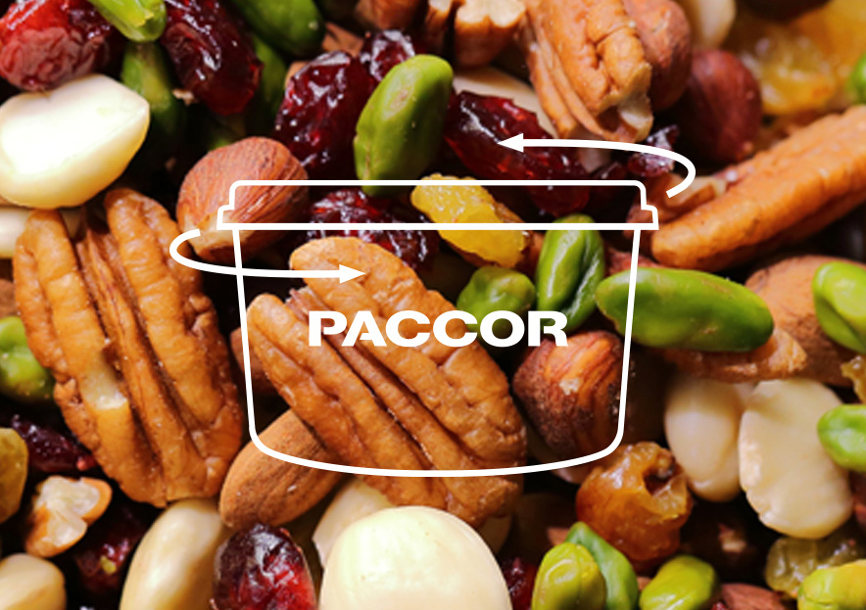

July 2nd, 2020

PACCOR LAUNCHES THE DELICIRCLE RANGE
Many manufacturers of plastic packaging are striving to design products which are more responsible, contain recycled material, and, in particular, which can be reused. PACCOR is taking the lead with the DeliCircle range, which is launched for on-the-go consumption. These thermoformed containers are made entirely from recycled polyethylene terephthalate (rPET).

Equipped with an airtight lid, which is adapted to the four formats and treated to prevent fogging, the containers are resealable and allow consumption in several portions. Consumers will also be able to reuse them several times, whether for storing food at home, preparing take-away meals, or packaging mass products. An insert is available for separating components.

PACCOR specializes in rigid plastic packaging mainly for the food, feed, and on-the-go consumption markets, but also for hygiene, household, and pharmaceutical applications. The group has a turnover of EUR 590 million and 3,000 employees at 16 production sites in 15 countries in Europe and the United States.

ABOUT PACCOR
At PACCOR we create innovative and sustainable packaging solutions for the consumer, food and foodservice market. Our overall goal is to protect what is worth being protected: our planet, our partners’ products and our employees. We have high expertise in developing and providing valuable rigid plastic packaging products. Our solutions meet current market trends by constantly thinking outside the box. With more than 3,000 dedicated employees in 15 countries, PACCOR is a global player in the packaging industry. Everything we do contributes to the protection and hygienic safety of valuable products. PACCOR leads the transition towards a circular economy. Because we believe this is the best way to achieve real change in the industry and to create shared value for all our stakeholders and society. More: https://www.paccor.com/

