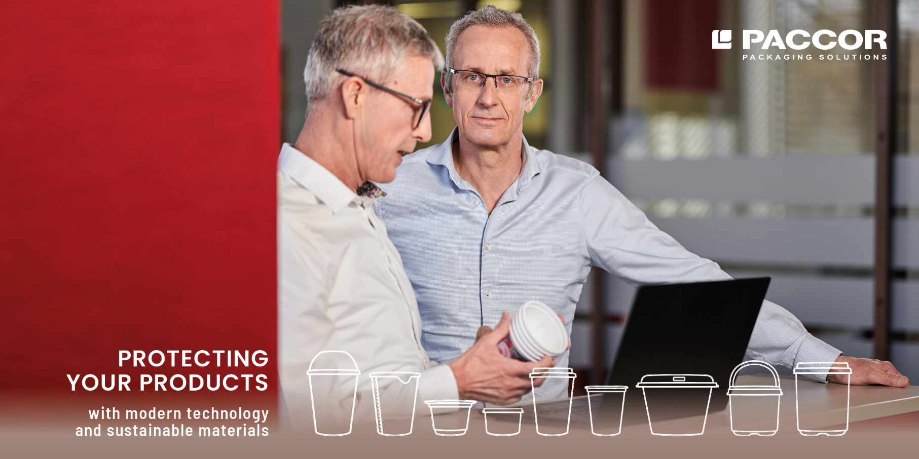

February 8, 2021
PACCOR INVESTS FOR CAPACITY EXPANSION
PACCOR, the leading global player in the packaging industry, is to invest more than 40 million euros in 2021. The demand for sustainable packaging has also increased in times of COVID-19 and PACCOR is responding to this demand. Investments are to be allocated to capacity increases, automation, logistics, and new technology. The raising of the manufacturing capacity at PACCOR’s production site in Ravensburg, as one part of the investment program, will now been finalised.

Requirements for efficient and sustainable food packaging are very high, and PACCOR is the perfect partner to fulfil such market demands with its dedicated production facilities throughout Europe.

PACCOR is now adding new injection molding capacities at its Ravensburg site in Germany. Most modern technology is being installed to produce in-mold labelled polypropylene (PP) cups and bi-colored lids. The injection molding process offers very precise dimensional product accuracy, achieving tightest tolerance levels. A perfect fit of individual components can be guaranteed as well as achieving high efficiency on customer filling lines.

“Our customers have invested in this growing segment and, of course, so have we. We are responding to the demand with additional injection molding and automation equipment and are now able to process newest materials. By applying specific advantages of the injection molding technology, we can fulfil market requirements,” outlines Andreas Schuette, CEO of PACCOR. “Mono-material and recyclability further contribute to fulfilling our sustainability goals and support our move from a linear to a circular economy,” adds Mr Schuette.

"PACCOR’s production site in Ravensburg has a lot of experience with injection molding. With its test facilities and its 24/7 production organization, we can react to fluctuations in demand at any time," concludes Michael Schorn, Managing Director of PACCOR Deutschland GmbH.

MEDIA CONTACT:
Sonja Teurezbacher
Vice President Group Communications & Marketing
communication@paccor.com

ABOUT PACCOR
At PACCOR we create innovative and sustainable packaging solutions for the consumer, food and foodservice market. Our overall goal is to protect what is worth being protected: our planet, our partners’ products and our employees. We have high expertise in developing and providing valuable rigid plastic packaging products. Our solutions meet current market trends by constantly thinking outside the box. With more than 3,000 dedicated employees in 15 countries, PACCOR is a global player in the packaging industry. Everything we do contributes to the protection and hygienic safety of valuable products. PACCOR leads the transition towards a circular economy. Because we believe this is the best way to achieve real change in the industry and to create shared value for all our stakeholders and society.

More: https://www.paccor.com/

