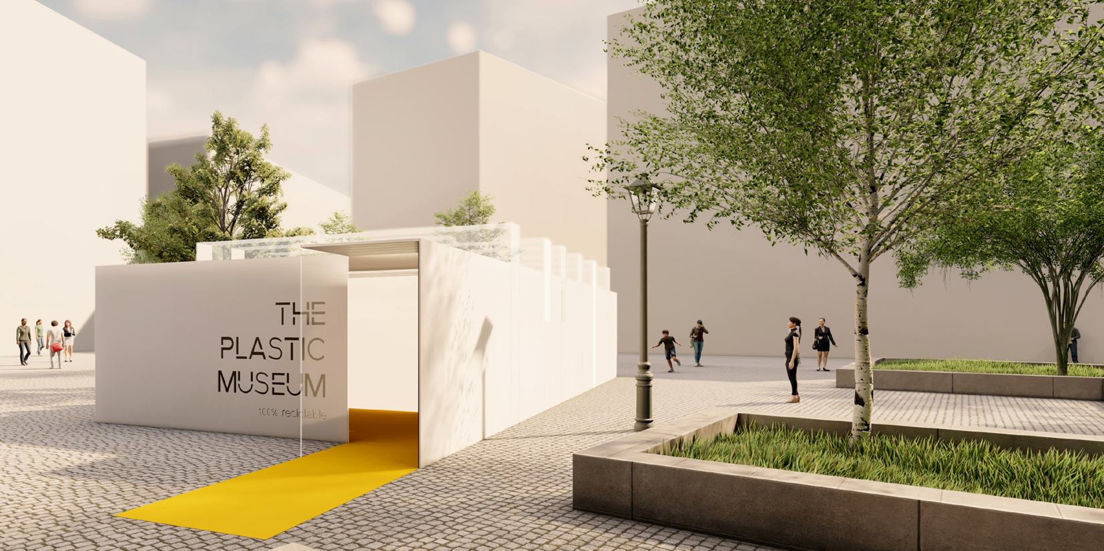
May 7, 2021, Dusseldorf, Germany

PACCOR HELPS BUILD A PLASTIC MUSEUM

On May 8, 2021, the ‘Museo de los Plasticos’ in Madrid will open its doors. PACCOR, a leading global player in the packaging industry, is one of the main sponsors of the project initiated by EsPlásticos. The museum, a space made 100 % of plastics, pays tribute to the various creations in plastics and highlights their unknown uses and unexpected utilities. It can only be visited for 10 days at the Plaza de Juan Goytisolo in front of Museo Reina Sofia, Spain’s National Museum in Madrid, as it will be fully recycled on World Recycling Day on May 17.
EsPlásticos, a plastics platform that serves as a point of union for the different agents in the sector and the plastics value chain, has been founded in November 2019. The founding partners are industry associations like Plastics Europe, Anaip, Aimplas, and Cicloplast. EsPlástico was created with the aim of making sustainable plastic solutions known as well as highlighting the technical, economic, social, and environmental advances of the sector. The main messages of this platform are focused on the circular economy, climate change, safety and health and marine litter. EsPlásticos informs about the benefits of plastic and awareness about the proper management of waste to reduce the environmental impact. In addition, innovation in the sector occupies a space of great relevance highlighting R&D projects related to recycling and sustainable development, among others.
“Thanks to initiatives such as EsPlástico, different agents in the sector join forces to reach a future of increasingly sustainable plastic,” explains Andreas Schütte, CEO of PACCOR. “Given the constant and prejudiced attacks that the plastic industry has been facing lately, EsPlásticos is now launching an original campaign that showcases the amazing properties of plastics, including its recyclability, and PACCOR is proud to be a part of it.”
The aim is to draw the attention of citizens, the media, opinion makers and politicians to raise awareness of the benefits of this material and the solutions it can provide. This unprecedented campaign is based on the construction of a Plastics Museum, a space made 100 % of plastics. The museum pays tribute to the various creations in plastics and highlights their unknown uses and unexpected utilities.
“All the evidence in favor of plastic that we usually do not perceive or do not value will be shown, thus generating new opinions that will contrast with the negativity that currently exists around its use,” says Koke Pursals, Managing Director of PACCOR Iberia S.A.
The peculiarity of this museum is that it announces its closing date already on the day of opening, which will be World Recycling Day on May 17, 2021. The Plastic Museum will be completely recycled to be used for other purposes, demonstrating the versatility of the material.
“EsPlásticos aims to show public opinion that another vision of plastic is possible, making recycling the focus of the conversation in all media,” concludes Caterina Camerani, VP Group Sustainability at PACCOR. “We need to generate debates around plastic materials and for them to be considered part of the solution and not just part of the problem.”

MEDIA CONTACT:
Sonja Teurezbacher
Vice President Group Communications & Marketing
communication@paccor.com

ABOUT PACCOR
At PACCOR we create innovative and sustainable packaging solutions for the consumer, food, and foodservice market. Our overall goal is to protect what is worth being protected: our planet, our partners’ products, and our employees. We have high expertise in developing and providing valuable rigid plastic packaging products. Our solutions meet current market trends by constantly thinking outside the box. With more than 3,000 dedicated employees in 15 countries, PACCOR is a global player in the packaging industry. Everything we do contributes to the protection and hygienic safety of valuable products. PACCOR leads the transition towards a circular economy. Because we believe this is the best way to achieve real change in the industry and to create shared value for all our stakeholders and society. More: https://www.paccor.com/

