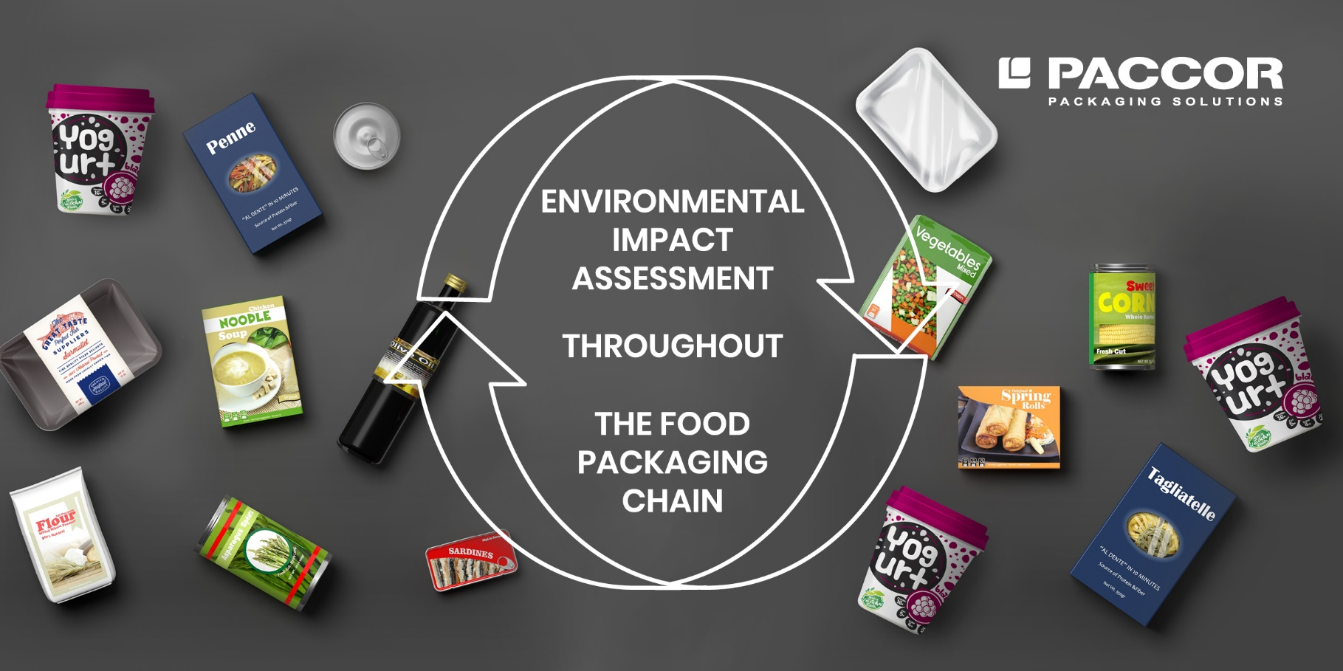
November 18, 2020
PACCOR HAS NOW JOINED THE
CIRCOPACK PROJECT
PACCOR, a global player in the packaging industry, has now joined the CIRCOPACK project which was initiated by Pack4Food – a consortium of companies active in the food and packaging industry and their suppliers – in collaboration with Flanders’ FOOD, SensNet and different research institutions. As a member PACCOR may actively participate in various research projects, stay on top of innovative developments in our sector, and conduct technical debates.

The choice of packaging remains a strategic and complex issue for food companies. At a time when circular economy is becoming the reference for businesses, the following questions arise: How will food packaging find its place in this circular economy trends? What role will it play? What are the most sustainable packaging solutions in the short and long term?
“The research project is about optimization of packaging solutions through environmental impact assessments, taking into consideration the overall food packaging chain, including the food filling process, food waste and end of life. The food products included in the project were chosen in a way that results could be easily extrapolated to other food types, making the validity of the findings applicable to a larger scale. We want to address consumers’ concerns about plastics with science-based facts," explains Andreas Schuette, CEO of PACCOR.
The CIRCOPACK project (April 1, 2019 until March 30, 2022) will deliver a scan for companies that turns it possible to make well thought decisions about the raw material selection for food packaging. This will provide the entire food supply chain with the necessary baggage and tools to optimize packaging policies in line with circular economy while maintaining the required packaging functionality and safety. As a consequence, companies will be able to make better targeted choices in their packaging concept.
"Besides, the scan should also make it possible for our members to deliver a scientific underpinned argumentation to their customers about the packaging choices being made," adds Peter Ragaert, Managing Director at Pack4Food.
Furthermore, CIRCOPACK will also lead to a closer collaboration between packaging producers, food producers, waste packaging processors and ultimately consumers. This in time will result in more efficient packaging innovations, where the goal is to strive towards maximum sustainability of the product-packaging combination and where the final recycling options are taken into account at the development of the packaging concept (design for recyclability).
"PACCOR is increasingly confronted with questions from different parties about the types of packaging and their impacts on the environment and safety. Via Life Cycle Analysis studies different plastic – virgin, recycled, fossil and biobased – and non-plastic packaging alternatives will be compared to one another for a number of selected food groups, to find the safest and most efficient food packaging within a circular economy," concludes Caterina Camerani, VP Group Sustainability at PACCOR.

MEDIA CONTACT:
Sonja Teurezbacher
Vice President Group Communications & Marketing
communication@paccor.com

ABOUT PACCOR
At PACCOR we create innovative and sustainable packaging solutions for the consumer, food and foodservice market. Our overall goal is to protect what is worth being protected: our planet, our partners’ products and our employees. We have high expertise in developing and providing valuable rigid plastic packaging products. Our solutions meet current market trends by constantly thinking outside the box. With more than 3,000 dedicated employees in 15 countries, PACCOR is a global player in the packaging industry. Everything we do contributes to the protection and hygienic safety of valuable products. PACCOR leads the transition towards a circular economy. Because we believe this is the best way to achieve real change in the industry and to create shared value for all our stakeholders and society.
More: https://www.paccor.com/

