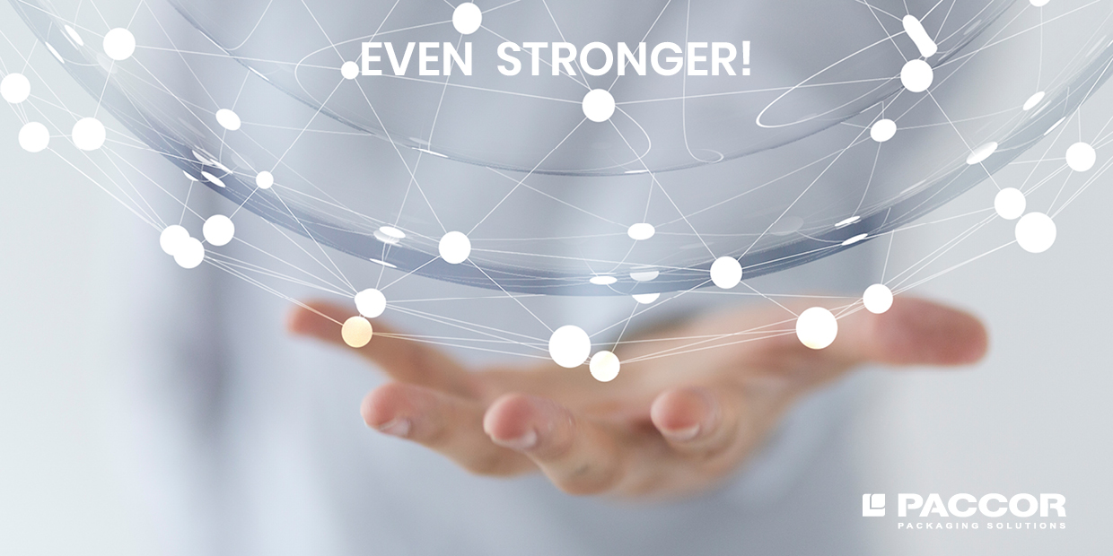

March 31, 2021, Düsseldorf, Germany

PACCOR ACQUIRES MIKO PAC N.V.

On March 30, 2021, PACCOR, a leading global player in the packaging industry, signed a purchase agreement for the acquisition of Miko Pac, the packaging division of Miko N.V., Belgium. The acquisition strengthens PACCOR's position in injection molding by complementing the product portfolio and expanding the company's competencies. Miko Pac’s plant in Indonesia extends PACCOR’s international reach and the fast-growing Asian market can now also be served.

Miko Pac is a world leader in plastic packaging production with many years of expertise and a strong dose of creativity. They develop and produce innovative solutions for ready meals, ice cream, margarine, and many other products.

Miko Pac employs approximately 500 people at its production sites in Belgium, Poland, and Indonesia and at its sales offices in France and Germany. Founded more than 45 years ago, Miko Pac is a specialist in thermoforming, injection molding and in-mold labelling.

Miko Pac will be integrated into PACCOR and its operational management will remain in the hands of its former co-owners and Managing Directors, Kristof Michielsen and Karl Hermans.

The parties have agreed not to disclose the purchase price. The acquisition is expected to be completed in the second quarter of 2021, after approval by the relevant competition authorities.

Andreas Schütte, CEO of PACCOR: “Following the purchase of the EDV Packaging Solutions, S.A., in 2019, our acquisition of Miko Pac is the logical next step in implementing our long-term business strategy and an excellent fit for our defined M&A strategy. Miko Pac’s innovative capabilities will further add to strengthen our ability to meet the needs of our customers. This acquisition aligns PACCOR even more strongly for growth within this highly promising area of business.”

Frans Van Tilborg, CEO of Miko: “After years of successful growth, we now see in PACCOR the perfect partner and owner to take the business forward and further globalize its market position. Both companies have a strong innovation culture. We are committed to serving the best interests of our customers, are using the latest methods and processes and have continually invested in the best R&D infrastructure.”

MEDIA CONTACT:
Sonja Teurezbacher
Vice President Group Communications & Marketing
communication@paccor.com

ABOUT PACCOR
At PACCOR we create innovative and sustainable packaging solutions for the consumer, food, and foodservice market. Our overall goal is to protect what is worth being protected: our planet, our partners’ products, and our employees. We have high expertise in developing and providing valuable rigid plastic packaging products. Our solutions meet current market trends by constantly thinking outside the box. With more than 3,000 dedicated employees in 15 countries, PACCOR is a global player in the packaging industry. Everything we do contributes to the protection and hygienic safety of valuable products. PACCOR leads the transition towards a circular economy. Because we believe this is the best way to achieve real change in the industry and to create shared value for all our stakeholders and society. New York-based investment firm Lindsay Goldberg acquired Coveris Rigid in August 2018 and renamed it PACCOR. More: https://www.paccor.com/

ABOUT MIKO PAC
As a subsidiary of Miko N.V., Miko Pac has been active in plastics packaging for some 45 years. In 2020, the plastics processing group achieved a turnover of more than 100 million euros and employs about 500 employees. Miko Pac has its own production sites in Belgium, Poland, Indonesia, and sales organizations in Germany and France. More: https://mikopac.com/en/

