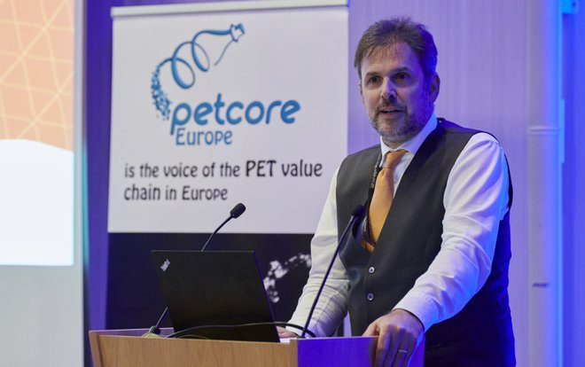

April 3rd, 2020

GETTING RID OF PLASTIC PACKING IS NOT A SOLUTION

At this year’s Petcore Europe Annual Conference in Brussels, Belgium, Mr. Nicolas Lorenz, PACCOR’s Chief Commercial Officer, during his speech presented how a new approach, including deployment of new technologies, cooperation within the industry and building direct communication channels with end-customers, will help to tackle the challenge and shift the approach to the plastic sector.

Prohibiting or eliminating plastic packaging is not the right step for both environmental protection and the economy. Plastic packaging allows for better protection of food and human health. Without packaging of e.g. fruit and vegetables, tons of plastic could be saved every year, but at the same time, food waste will increase enormously because shelf-life can be extended substantially.

Mr. Lorenz presented how new technologies can change the current status quo in the plastic packing industry. Digital watermarks are amongst the technologies which allows to take advantage of closed loop or circular solutions, and as such reduce the amount of disposable plastic. PACCOR’s partnership with Digimarc towards the application of digital watermarks in plastic food packaging is a perfect example of how to improve the sorting of used plastic products up to 100%, e.g for PET trays.
By integrating a subtle barcode into a plastic mold, every single plastic product produced out of such
a mold carries a “digital recycling passport.” The barcode also allows for the possibility to detect opaque, carbon-black, and other difficult-to-recycle objects, increasing both the quantity and quality of recyclates needed to meet regulatory requirements and corporate pledges.

PACCOR’s CCO also encouraged industry players to work together and establish new communication channels, direct ones, with end-consumers using new technologies and social media for immediate interaction. As a result, plastic packaging manufacturers can fully explain, accurately present and disclose the role of plastic in the entire supply chain – from producers to final consumers. He also added that an active consumer can continue to contribute in key areas of digitization, marketing, and communication.

ABOUT PACCOR
At PACCOR we create innovative and sustainable packaging solutions for the consumer, food and foodservice market. Our overall goal is to protect what is worth being protected: our planet, our partners’ products and our employees. We have high expertise in developing and providing valuable rigid plastic packaging products. Our solutions meet current market trends by constantly thinking outside the box. With more than 3,000 dedicated employees in 15 countries, PACCOR is a global player in the packaging industry. Everything we do contributes to the protection and hygienic safety of valuable products. PACCOR leads the transition towards a circular economy. Because we believe this is the best way to achieve real change in the industry and to create shared value for all our stakeholders and society.

More: https://www.paccor.com/

