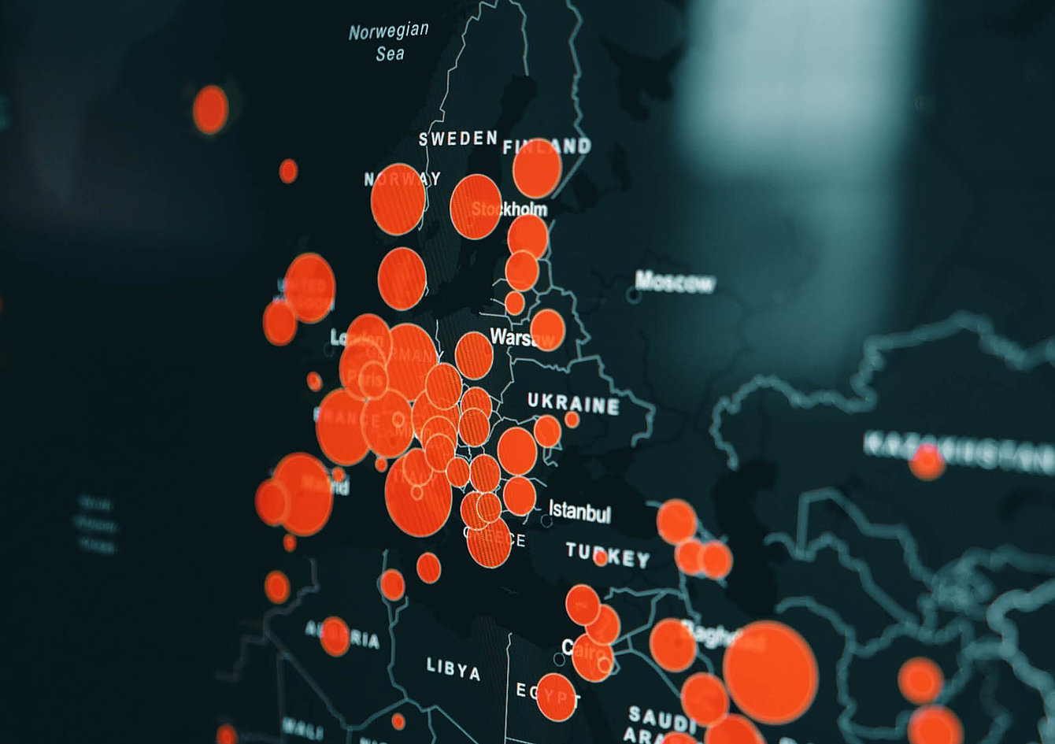

May 14th, 2020

CORONAVIRUS’ BUSINESS IMPACT

The outbreak of COVID-19 has had increasing implications on the global economy, hundreds of millions of individual companies, and over one fourth of the global population. What conclusions could businesses and manufacturers like PACCOR take from these turbulent and exceptional times?

The pandemic continues to spread worldwide and almost every nation has reported thousands or even hundreds of thousands of cases. But in many countries, and largely in Europe, after 2 months of fighting, lockdowns, and overwhelming chaos, the situation is beginning to slowly normalize, mainly due to the decrease in new cases. That situation has allowed governments to gradually lift restrictions, re-open their economies and return to normality.

BUSINESS PERSPECTIVE

The last 8 weeks were both unexpected and hard to handle for most companies globally. Some sectors have already suffered significantly, and some will in the months to come. Taking into account all current circumstances, the come back to business as usual is bumpy and there is still a long way to go. But for some companies, including PACCOR, these demanding times can allow organizations to unite and strengthen.

Despite the fact that the economy will not return to the state before the pandemic soon, we have tuned into this situation together with all our stakeholders. – said Mr. Andreas Schütte, the PACCOR’s CEO. – Taking care of them, i.e. our employees, local communities, protecting customer’s interests, and cooperating responsibly with our suppliers in these challenging times will allow us to continue business in a sustainable way. – added the Head of PACCOR.

PACCOR Group has been able to operate and provide deliveries to customers, with a focus on essential sectors like the food industry and households, thanks to their well-coordinated and committed teams. All company plants have constantly manufactured products without compromising the health and safety of their employees. Additionally, the company has also supported staff facing extraordinary challenges due to the closing of kindergartens and schools with home office and special change patterns for collaborators in production halls. Although hygiene standards have always been high in the Group, the additional efforts of local teams ensured a controlled environment in all sixteen factories in Europe and the United States.

NEW STRATEGY

PACCOR’s business DNA is based on continuous learning and development of the company and products. The pandemic has allowed them to test procedures, developed new processes, and incorporate results into the organization, in case similar circumstances impact the economy once again.

The company’s business approach also manifests in permanent work on improvements in sustainable plastic packaging products. New material solutions have been identified that will be further tested in normal production. In addition, positive results have come from PACCOR’s partnership with Digimarc in relation to the deployment of digital watermarks to improve the detection and sorting of plastics by up to 100 percent, e.g for PET trays.

These changes in PACCOR’s operations during these turbulent times coincide with the work related to the Group’s new CARE strategy. The official launch of it is expected to be revealed and reported in the coming weeks.

ABOUT PACCOR
At PACCOR we create innovative and sustainable packaging solutions for the consumer, food and foodservice market. Our overall goal is to protect what is worth being protected: our planet, our partners’ products and our employees. We have high expertise in developing and providing valuable rigid plastic packaging products. Our solutions meet current market trends by constantly thinking outside the box. With more than 3,000 dedicated employees in 15 countries, PACCOR is a global player in the packaging industry. Everything we do contributes to the protection and hygienic safety of valuable products. PACCOR leads the transition towards a circular economy. Because we believe this is the best way to achieve real change in the industry and to create shared value for all our stakeholders and society.

More: https://www.paccor.com/

