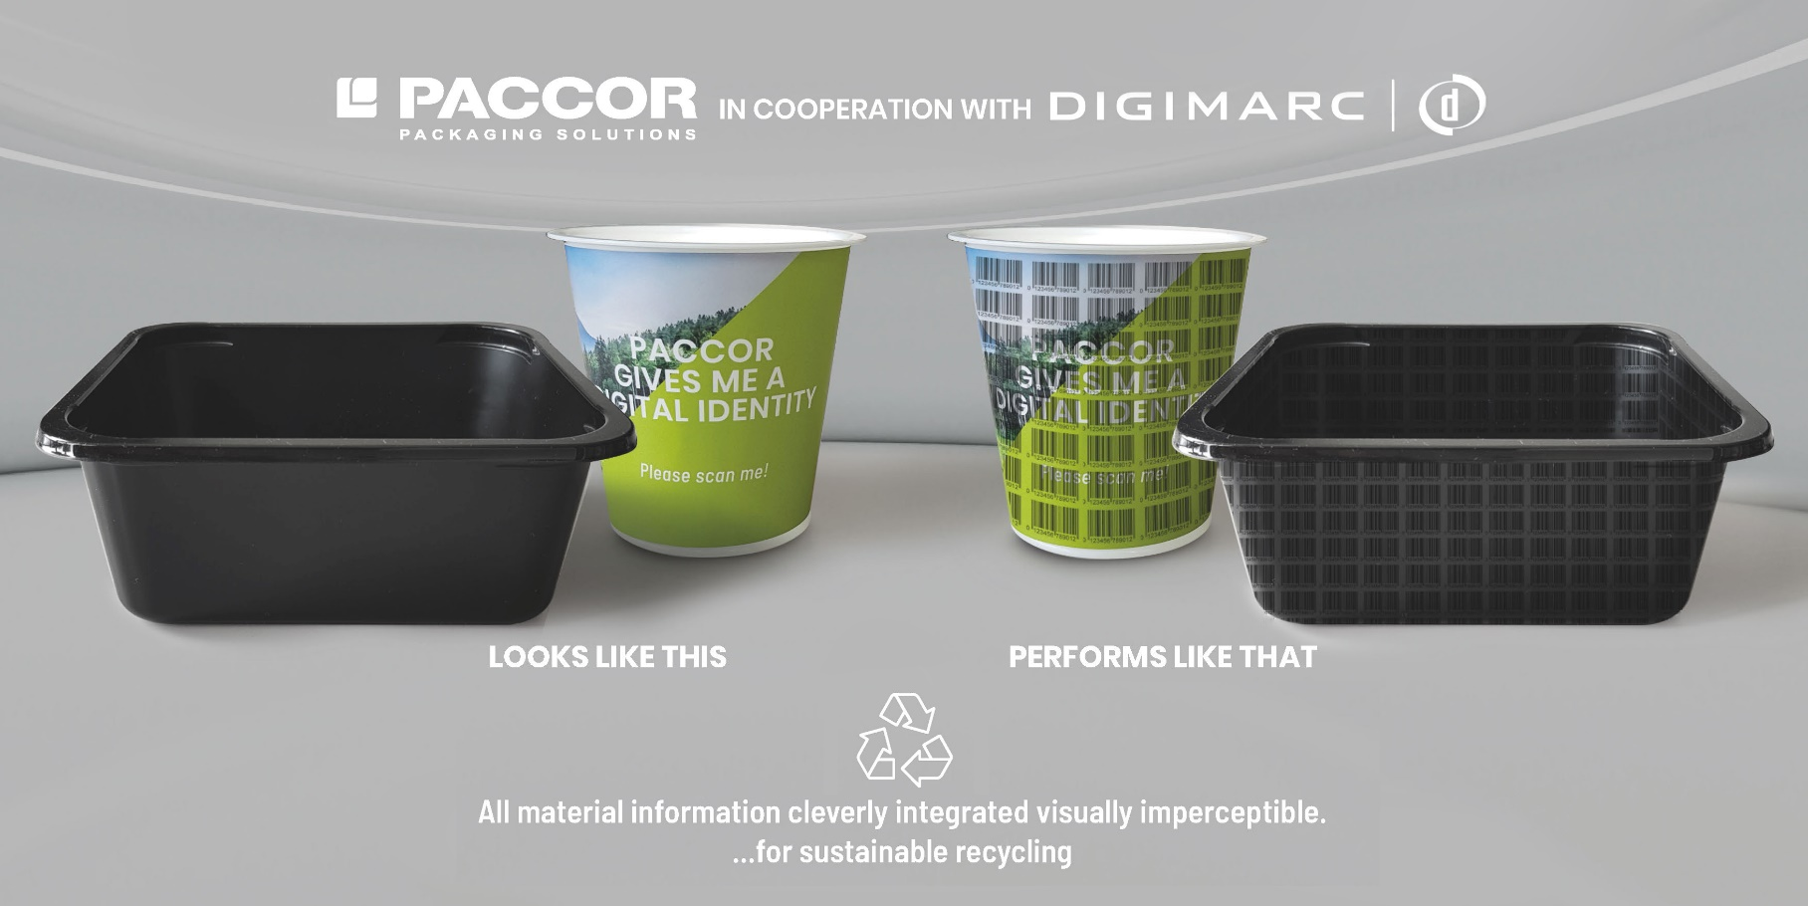

March 9, 2021

PACCOR AND DIGIMARC TAKE THEIR PARTNERSHIP TO THE NEXT LEVEL

PACCOR, the leading global player in the packaging industry, has been designated by Digimarc, the inventor of the Digimarc Platform for automatic identification (NASDAQ: DMRC), as a Platinum Pioneer Plastics Partner. This designation recognizes the substantial contributions to the joint projects to date. Together, both companies now take the next step to provide plastic packaging solutions with digital identities. The objectives of this partnership are to develop and commercialize a solution for high-speed sorting of plastic packaging items with Digimarc Barcode, for the purpose of increasing the recyclability and circularity of the plastic packaging products.

As a strategic partner, Digimarc provides PACCOR with technical advice, support and access to the Digimarc Platform. PACCOR provides Digimarc with access to and support from its Centre of Development & Innovation (CDI) to advance the state of the art in the enhancement of plastic packaging solutions for recycling and circularity.

“This close cooperation will certainly accelerate the marketability of products enhanced with Digimarc Barcode," outlines Nicolas Lorenz, CCO of PACCOR. “We are pleased to offer our customers licensing rights if they want to incorporate Digimarc into their packaging.”

PACCOR is able to apply Digimarc Barcode using various technologies, such as thermoforming, injected and compression molding labelling, as well as in printing on all decorative options (plastic sleeve and paper banderole). Digimarc Barcode can be engraved in the mold or printed on a label on the outer packaging to give the package a “digital intelligence,” turning it into an Internet of Things object. Digimarc can be detected by a wide variety of machines and smartphones.

“We are looking forward to seeing the first thermoform product on shelf made by PACCOR embossed with the Digimarc Barcode,” states Larry Logan, Chief Evangelist at Digimarc. “Our clear target is that PACCOR or their customers get their own thermoforms back from sorting plants,” concludes Larry Logan.

For print, the process takes the existing design and enhances the artwork with Digimarc. There are no special inks or printing processes required. The artwork can be used in supply chains to track and trace goods, to speed retail checkout and engage and inform consumers through smartphones. For 3D in plastics, PACCOR engraves Digimarc into the mold, creating a subtle decorative embossing effect. In essence, the plastic is given what Digimarc has termed a “Digital Recycling Passport." Now, when packaging waste is collected, it can be scanned and absolutely identified. This will create new value streams for recycled plastics and keep used packaging from ending up in landfills and in our oceans.

“We are pleased PACCOR is our first Platinum Pioneer Plastics Partner,” said Robert Chamness, Digimarc’s EVP of Sustainability. “For almost two years, we have been collaborating with PACCOR, one of the world’s largest suppliers of rigid plastic packaging. PACCOR has been an ardent supporter of Digimarc Barcode. We have acknowledged them with this new Platinum designation in recognition of their innovative practices, their investment in research and development, the leadership position they have achieved in packaging sustainability and their commitment to the commercialization of our Platform.”

“PACCOR’s initiative and demonstrated success in creating 3D substrates will further fuel the adoption of digital identifiers in packaging materials,” said Larry Logan, Digimarc’s Chief Evangelist for recycling and sustainability. “This is an important step in the HolyGrail 2.0 initiative and the various other efforts underway to help brands meet their public pledges for recyclability and the regulatory mandates for recycled content. And, the timing of our relationship is particularly relevant with the recent gaps in the supply of virgin plastics through force majeure actions, pointing again to the need for a vibrant supply of post-consumer recyclate for new products.”

Digimarc Barcode, along with Digimarc Discover identification software and Digimarc Verify for quality control, comprise the Digimarc Platform for automatic identification of objects. The Platform has nearly endless applications, including for manufacturing, supply chain and logistics, and helping retailers and consumer brands meet the complex challenges of today's marketplace.

MEDIA CONTACT:
Sonja Teurezbacher
Vice President Group Communications & Marketing
communication@paccor.com

Heidi Dethloff, Digimarc
VP, Marketing and Director of Corporate Communications
Heidi.Dethloff@digimarc.com
503-469-4974

ABOUT PACCOR
At PACCOR we create innovative and sustainable packaging solutions for the consumer, food and foodservice market. Our overall goal is to protect what is worth being protected: our planet, our partners’ products and our employees. We have high expertise in developing and providing valuable rigid plastic packaging products. Our solutions meet current market trends by constantly thinking outside the box. With more than 3,000 dedicated employees in 15 countries, PACCOR is a global player in the packaging industry. Everything we do contributes to the protection and hygienic safety of valuable products. PACCOR leads the transition towards a circular economy. Because we believe this is the best way to achieve real change in the industry and to create shared value for all our stakeholders and society.

More: https://www.paccor.com/

ABOUT DIGIMARC
Digimarc Corporation (Nasdaq: DMRC) is the inventor of the Digimarc Platform that enables a more efficient, reliable and economical means of automatic identification. The Digimarc Platform can apply a unique identifier to virtually all media objects—including product packaging, commercial print, audio and video—that can be automatically identified by an enabled ecosystem of industrial scanners, smartphones and other interfaces. The Platform enables applications and solutions including brand protection, traceability, and recycling that benefit retailers and consumer brands, national and state government agencies, media and entertainment industries, and others. Digimarc is based in Beaverton, Oregon, with a growing supplier network around the world.

Visit www.digimarc.com and follow us on LinkedIn and Twitter to learn more about The Barcode of Everything®.

